**Programação Arduino IDE 27/03/2024**

**Semáforo + Semáforo de Pedestres + Luz vermelha piscando “ALERTA”**

**NOME:** Bruno Henrique da Silva Pereira

**Imagens:**

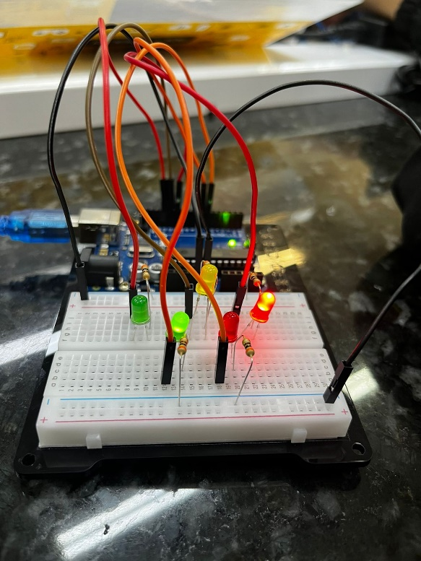

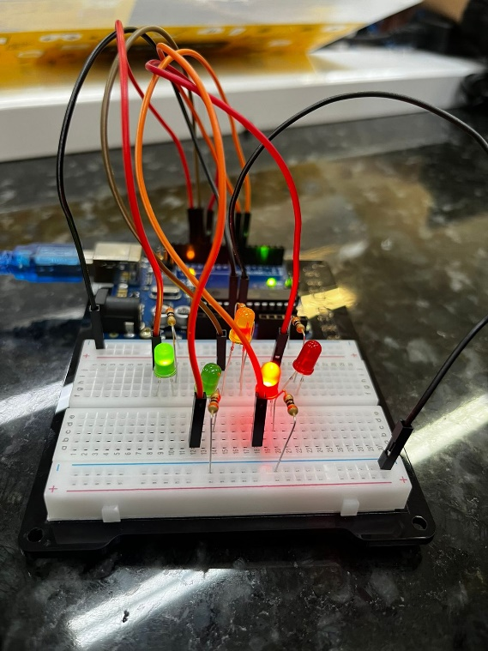

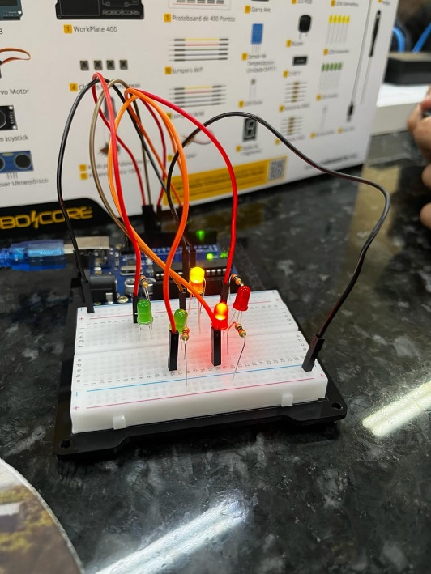

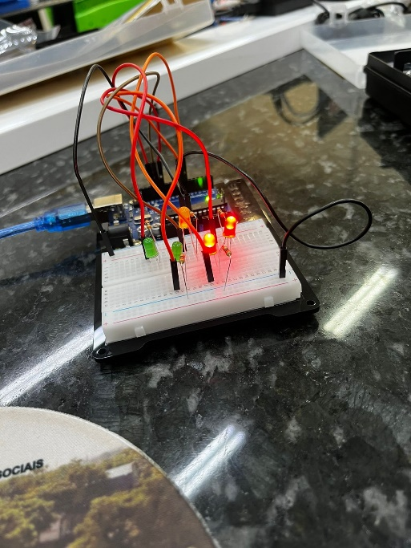

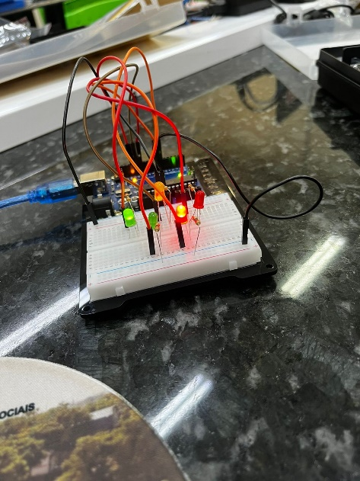

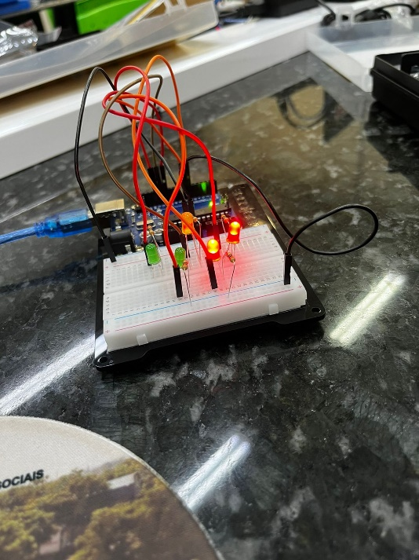

**Programação:**

int led[5];

void setup()

{

led[0] = 13;

led[1] = 12;

led[2] = 11;

led[3] = 7;

led[4] = 6;

pinMode(led[0], OUTPUT);

pinMode(led[1], OUTPUT);

pinMode(led[2], OUTPUT);

pinMode(led[3], OUTPUT);

pinMode(led[4], OUTPUT);

}

void loop()

{

digitalWrite(led[0], LOW);

digitalWrite(led[1], HIGH);

digitalWrite(led[2], LOW);

digitalWrite(led[3], LOW);

digitalWrite(led[4], HIGH);

delay(1000);

digitalWrite(led[0], LOW);

digitalWrite(led[1], LOW);

digitalWrite(led[2], HIGH);

digitalWrite(led[3], HIGH);

digitalWrite(led[4], LOW);

delay(2000);

digitalWrite(led[3], LOW);

digitalWrite(led[4], HIGH);

delay(500);

digitalWrite(led[3], LOW);

digitalWrite(led[4], LOW);

delay(500);

digitalWrite(led[3], LOW);

digitalWrite(led[4], HIGH);

delay(500);

digitalWrite(led[3], LOW);

digitalWrite(led[4], LOW);

delay(500);

digitalWrite(led[0], HIGH);

digitalWrite(led[1], LOW);

digitalWrite(led[2], LOW);

digitalWrite(led[3], LOW);

digitalWrite(led[4], HIGH);

delay(2000);

}